MULTIPLICATION PROBLEMS
KS1 – 2001 Paper
1.
12 apples

KS1 – 2002 Paper
2.
3.
KS1 - 2003 Paper 1
4.
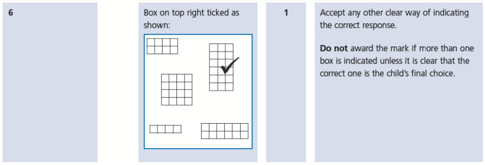
KS1 – 2004 Paper 1
5.
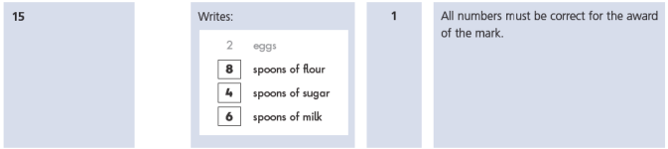
6.
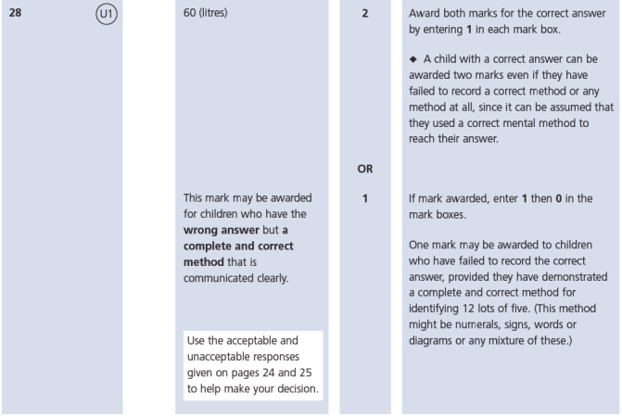
KS1 – 2004 Paper 2
7.
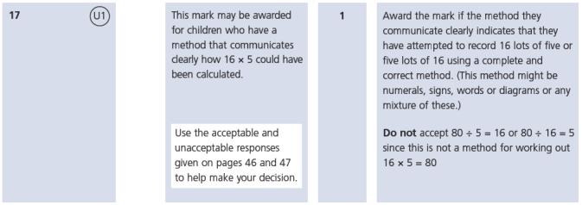
KS1 – 2005 Paper 1
8.
60

KS1 – 2005 Paper 2
9.
96

KS1 – 2007 Paper 2
10.
11.
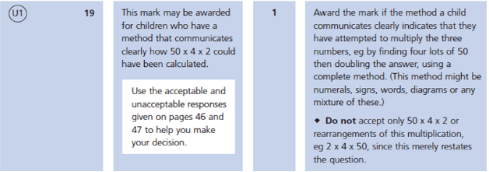
KS1 – 2009 Paper 1
12.
KS1 – 2009 Paper 2
13.
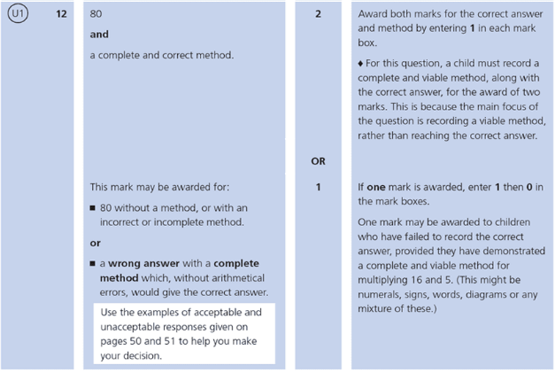

KS1 – 2016 Paper – Reasoning (Second)
14.
KS1 – 2017 Paper – Arithmetic
15.
KS1 – 2017 Paper – Reasoning
16.
17.
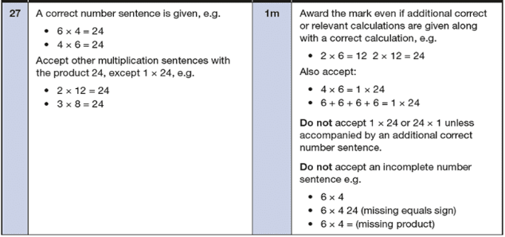
KS1 – 2018 Paper – Arithmetic
18.
KS1 – 2018 Paper – Reasoning
19.
20.
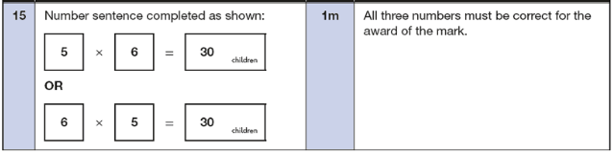
KS1 – 2019 Paper – Reasoning
21.
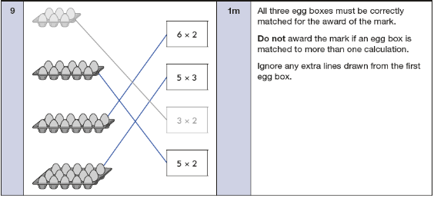
22.
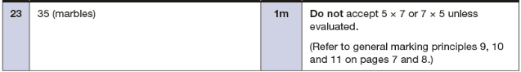
KS1 – 2022 Paper – Reasoning
23.
24.

